2022 PAUL BATALDEN AWARD
Call for Nominations!

The VA Quality Scholars (VAQS) Alumni Committee and the VAQS Coordinating Center are seeking applications for the 2022 Paul Batalden Award, which will recognize a VAQS graduate’s outstanding accomplishments in the field of healthcare improvement and patient safety. The winner of the award will be invited to speak at the 2022 VAQS Summer Institute.

All VAQS Alumni who completed fellowship May 2015 or earlier are eligible. Current VAQS faculty are eligible to apply if they are VAQS alumni. The award will be a cumulative career award and will recognize the individual’s accomplishments throughout their career. Both self-nominations and nominations from others will be considered.

If you are interested in applying or nominating someone for the 2022 Paul Batalden Award, please return the attached application and a copy of the nominee’s CV by March 1st, 2022 to javeria.qadri@bcm.edu.
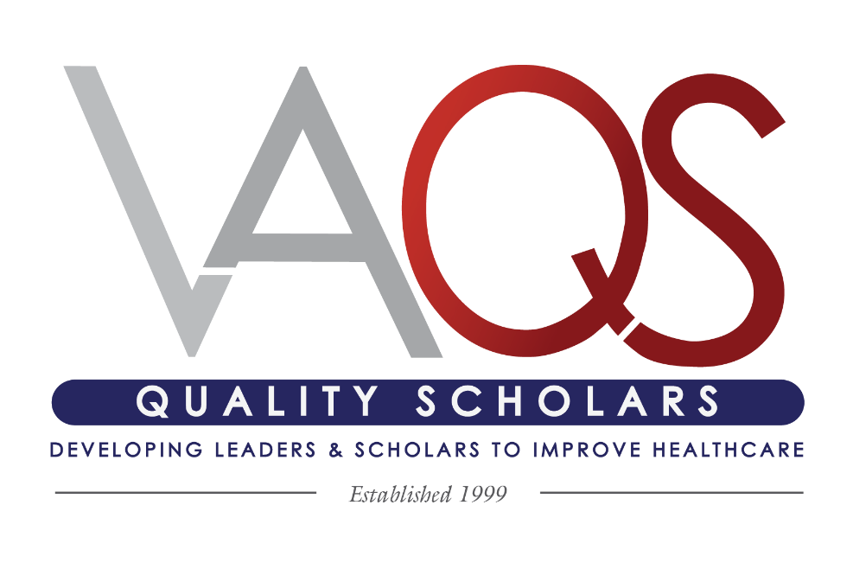
The winner will be announced at the beginning of May.
All VAQS Alumni who completed fellowship May 2015 or earlier are eligible. Current VAQS faculty are eligible to apply if they are VAQS alumni. The award will recognize the individual’s cumulative accomplishments throughout their career. Both self- nominations and nominations from others will be considered.

Person Submitting Nomination:
Nominee First Name: | Nominee Last Name:
Credentials: | Current Position:
Graduating Year: | VAQS Site Attended:
Phone Number: | Email:

Please complete all applicable fields below in the context of the individual’s accomplishments to healthcare improvement and patient safety. The candidate does not necessarily need accomplishments in all domains to be considered. The contents of this application will be the sole source of information considered by the selection committee. Please provide your nomination in the format of this application for consideration of your nominee.
Note: * There is a word limit of 300 words per section*
- Please highlight specific improvement and safety projects to which the nominee has made substantial contributions. Please highlight the impact and sustainability/spread of these programs as applicable.

- Please highlight specific education initiatives in improvement and safety to which the nominee has made substantial contributions.

*Please continue application on the next page for sections C-E.

- Please highlight the nominee’s contributions to leadership and operations within their organization.

- Please highlight the nominee’s contributions to scholarship including its relation to healthcare improvement, patient safety, implementation science and its impact on improving care.

- Please provide any additional details that you feel are important for the nominee’s application.

